**DIGITAL MARKETING PROJECT**

**Brand name :** Simon Studio and photography

**Category :** Studio and photography

**Team ID:** NM2023TMID02269

**EMAIL ID:** simonstudioandphotography@gmail.com

**Target audience :** All

**Target location :** Trichy , Tamil Nadu , India

**PROJECT TITLE :** PPC-AD-GOOGLE-ADS

**Logo:**

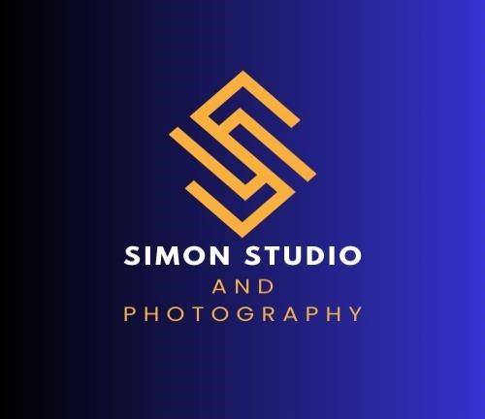

**DESCRIPTION:**

A photography studio is more than just a room with lights and cameras; it’s a space brimming with creative potential. Within these walls, photographers experiment with lighting, props, and backdrops, crafting a perfect ambiance for their subjects. Whether it’s a portrait session, a commercial shoot, or a creative project, studios provide the essential foundation for capturing mesmerizing images .

In today’s fast-paced world, where memories are made in an instant and cherished forever, the art of photography stands as a testament to our desire to capture the beauty of life. Within this realm, studios serve as sanctuaries for creativity and innovation, where photographers harness their skills to transform fleeting moments into timeless treasures.

**TEAM MEMBERS DETAILS:**

**NAME :** V.VIGNESHWARI

|  |  |
| --- | --- |
| **TEAM MEMBERS** | **TEAM ID** |
| P.SNEHA (TL) | 6BB6360715CBD3CAA78421ECAF096A6E |
| I.CATHRIN AISHA | B3F3A0C4724128A8C7541E946FDFC958 |
| R.MERCY | A25F3623DD74D1F9D994639555BE50E0 |
| V.VIGNESHWARI | 791F6001F570A5690ED48AEF9C52F831 |

**Step 1:** First we go to the link ,which is given in the NM-portal https://www.google.com/search?q=google+ads&rlz=1CIONGR_enl

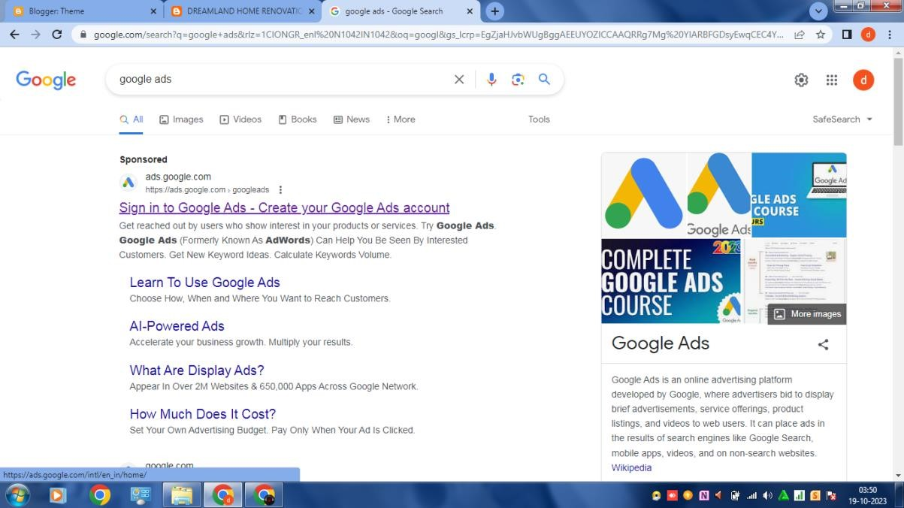

**Step 2:** Click the start now space

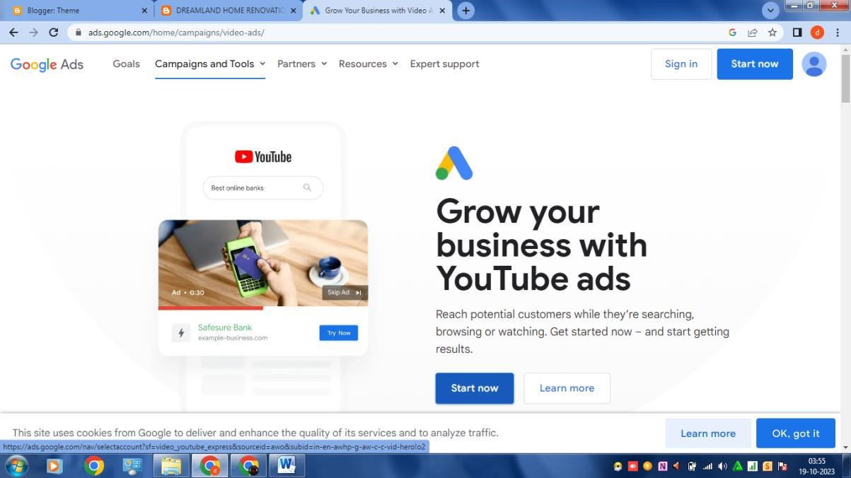

**Step 3:** Choose an email account which is created for your business page

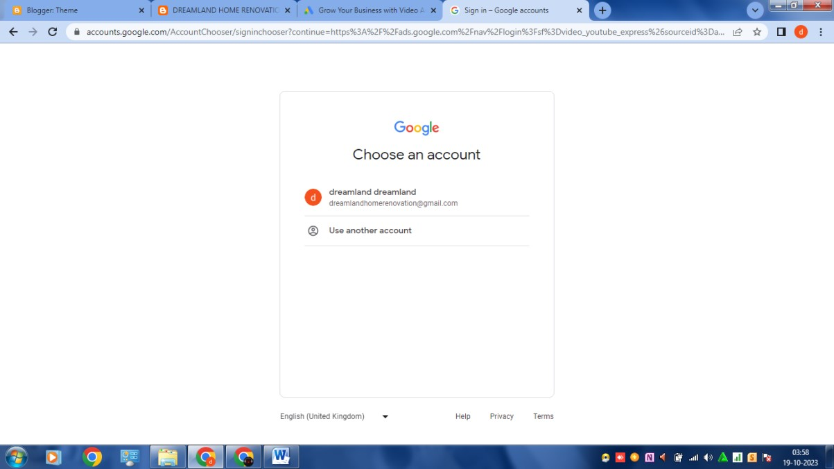

**Step 4:** Go to new campaign and choose campaign objectives:

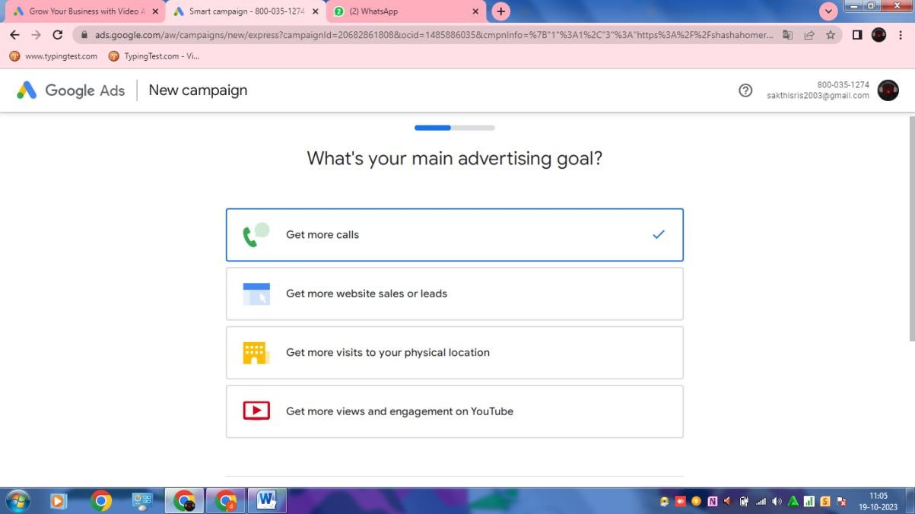

**Step 5:** Enter the website and campaign name:

Website: <https://dreamlandinhome.blogspot.com/>

Campaign name: DREAMLAND IN HOME RENOVATION

**Step 6:** select a location and language:

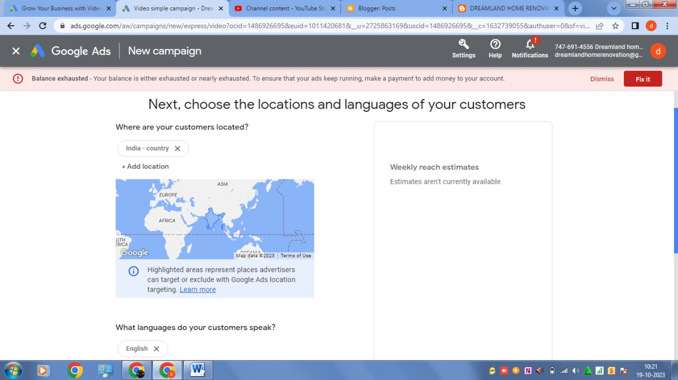

**Step 7:** Ad schedule and duration :

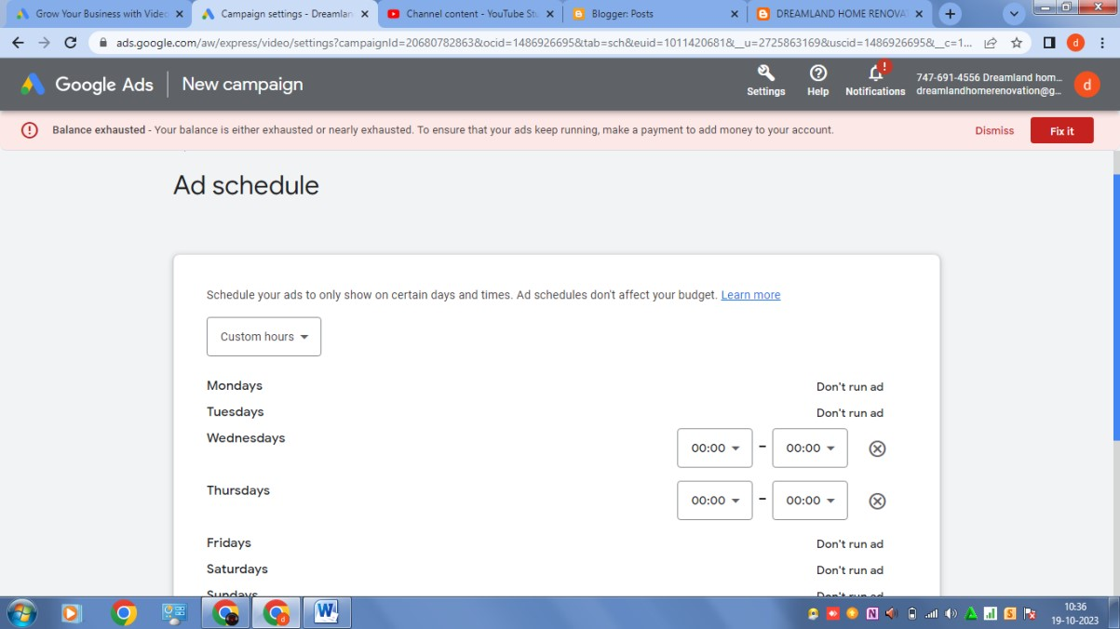

**STEP 8:** Ad budjet:

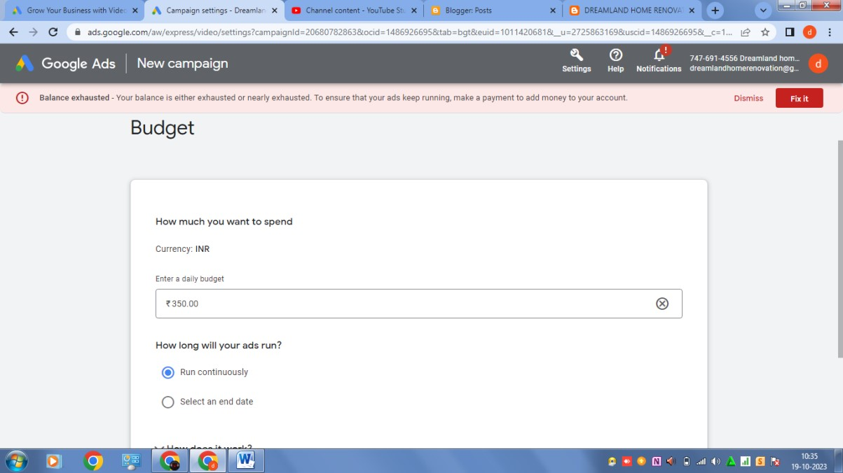

**Step 9:** Demographics:

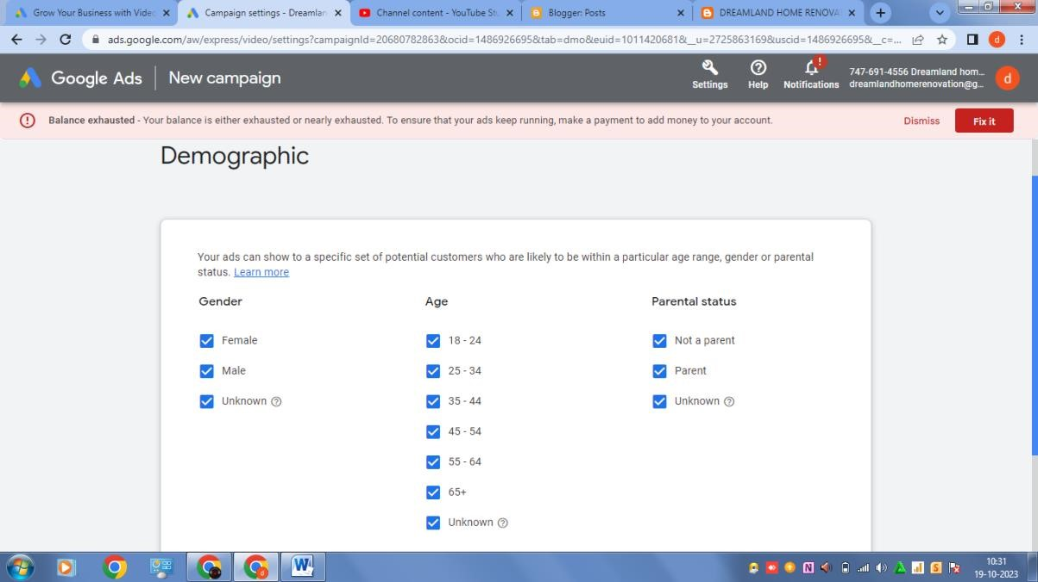

**Step 10** : keywords and topics:

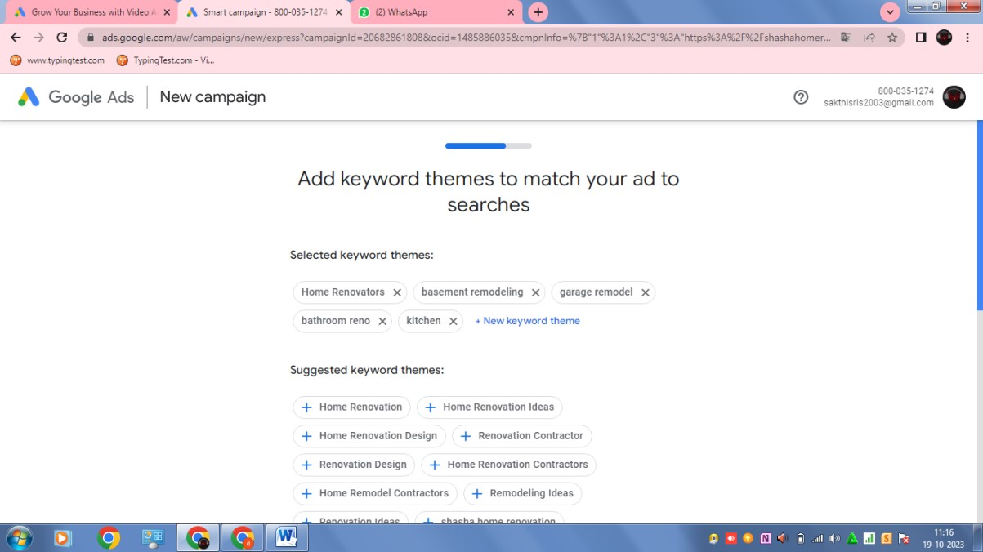

**Step 11:** Upload video:

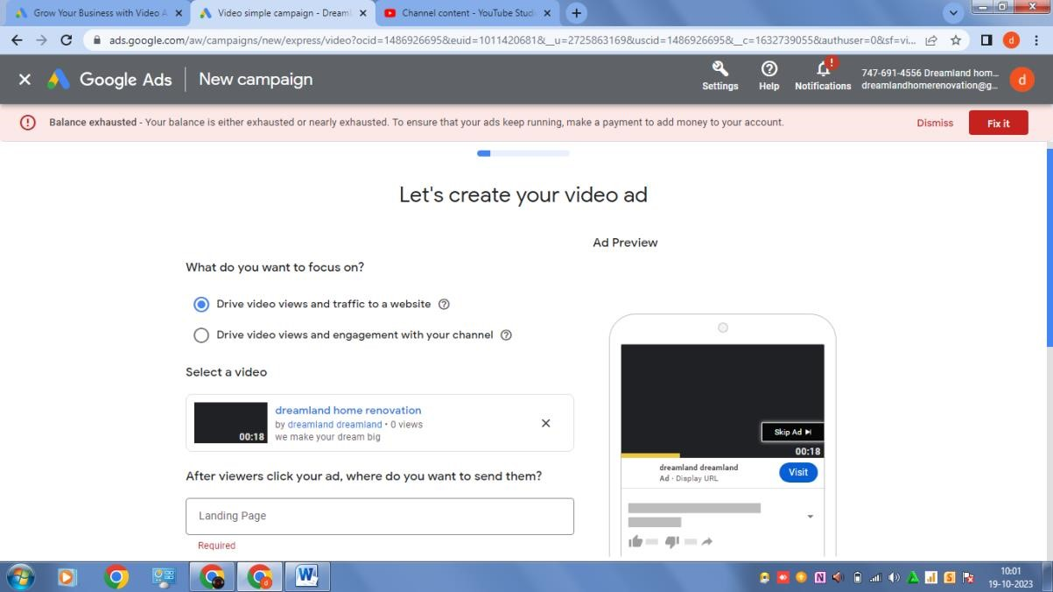

Video link: <https://youtu.be/1AVR9R1qTiY>

**Step 12:** Headlines and description

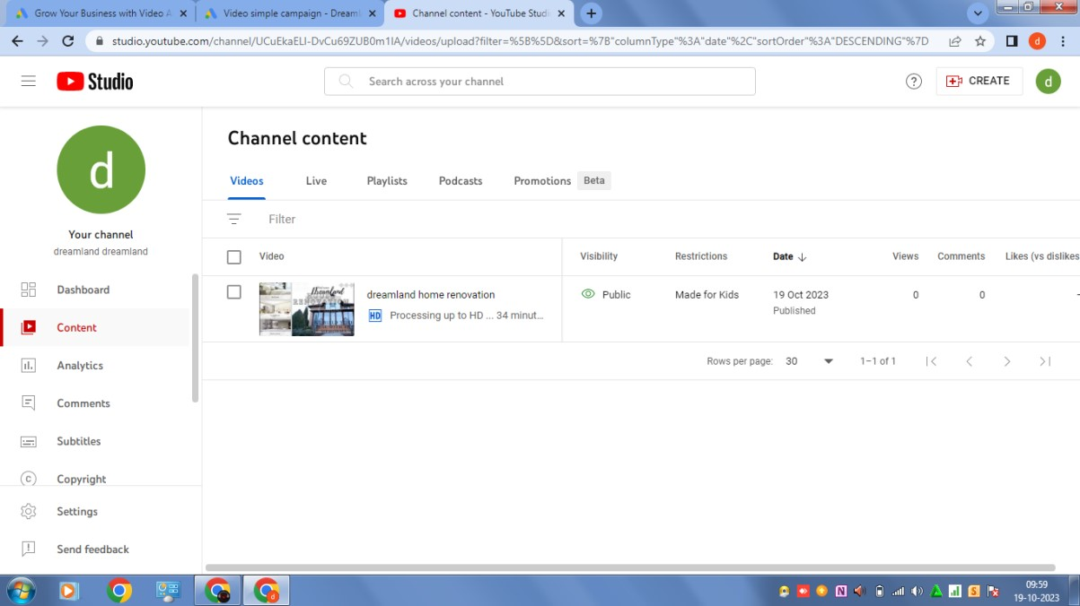

**Step 13:** publish and preview of google ads

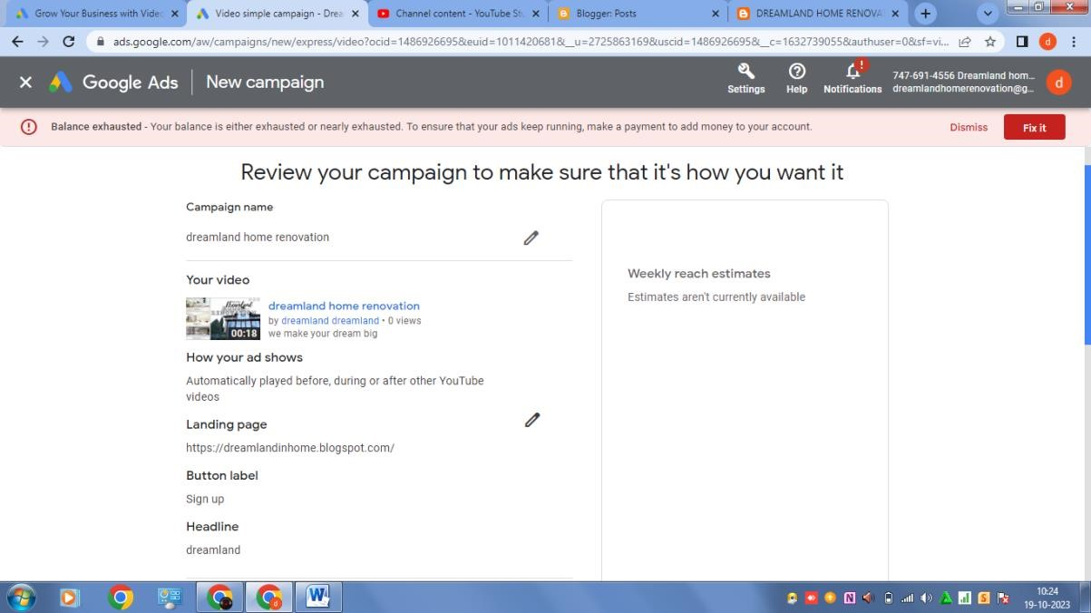

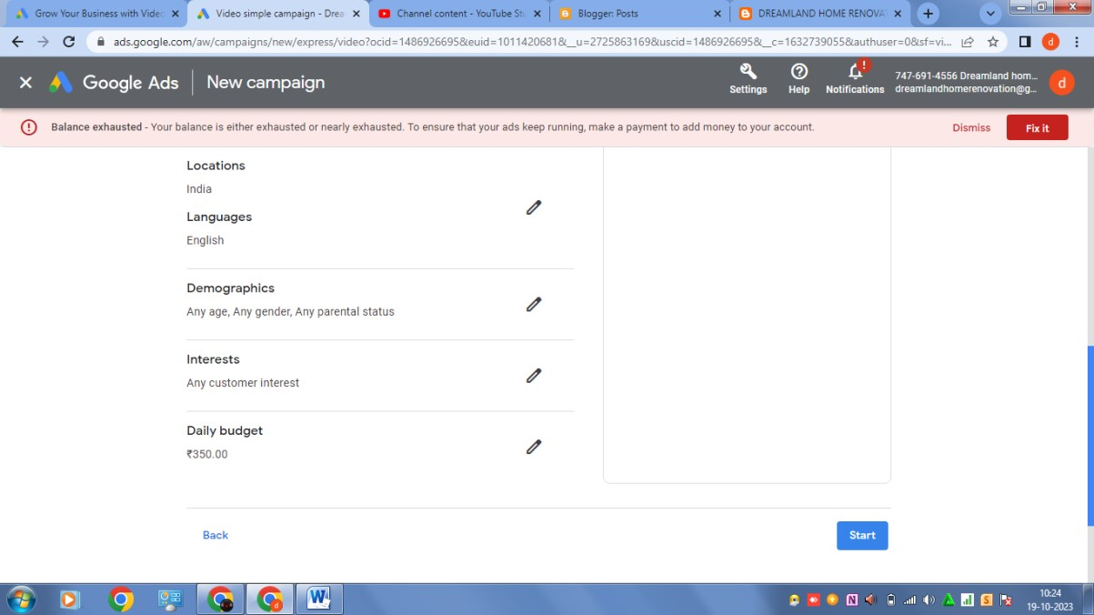

**Demo link :** https://youtu.be/pi8hkG4WZTk?si=3kLFlstD_LYOdjUS